**TASK-12**

Binary to Decimal Conversion

**EXPLANATION:**

The program asks the user to enter a binary number and then calculates its decimal value and displays as an output whereas if user enters a character the program displays an error message and returns the user to the starting of the program.

**INPUT:**

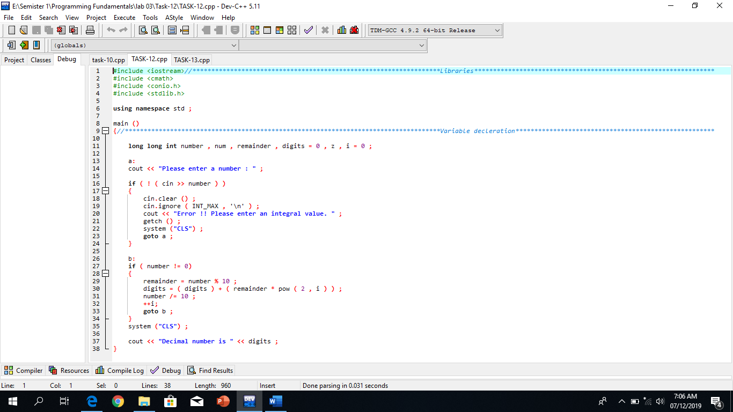

**OUTPUT:**

